Contents
1 Introduction 4
1.1 Purpose and Scope 4
2 BAFL Design 4
3 BSUL Design 4
4 initLocale Design 4
5 Activity Manager Design 5
5.1 Design Overview 5
5.2 Detailed Design 5
5.2.1 Overview 5
5.2.2 UML Diagram 5
5.2.3 Design Unit Behaviour 6
5.3 Scenarios 7
5.4 Design Considerations 9
5.4.1 Configurability and impact on Master Codeline 9
5.4.2 ROM/RAM Memory Strategy 9
5.4.3 Performance considerations 10
5.4.4 Error condition handling 10
5.4.5 Robustness issues 10
5.4.6 Localisation issues 10
5.4.7 Hardware/Platform assumptions 10
5.4.8 Compatibility considerations (Binary, Source, Data) 10
5.4.9 Interoperability considerations 10
5.4.10 Platform Security 10
5.4.11 Modularity 10
5.5 Testing 10
6 SysUtil Design 11
6.1 Design Overview 11
6.2 Detailed Design 11
6.2.1 Overview 11
6.2.2 UML Class Model Diagrams and Descriptions 12
6.2.3 General Design Comments 13
6.3 Scenarios 19
6.3.1 GetSWVersion, GetLangSWVersion, GetLangSWVersion and GetPRInformation Scenario 19
6.3.2 DiskSpaceBelowCriticalLevelL() Scenario 20
6.3.3 FFSSpaceBelowCriticalLevelL Scenario 21
6.3.4 MMCSpaceBelowCriticalLevelL Scenario 22
6.3.5 GetDeviceTypeInfoL() Scenario 23
6.4 Design Considerations 25
6.4.1 Configurability and impact on Master Codeline 25
6.4.2 ROM/RAM Memory Strategy 25
6.4.3 Performance considerations 25
6.4.4 Error condition handling 25
6.4.5 Robustness issues 25
6.4.6 Localisation issues 25
6.4.7 Hardware/Platform assumptions 25
6.4.8 Compatibility considerations (Binary, Source, Data) 25
6.4.9 Interoperability considerations 25
6.4.10 Security Threats and Measures 26
6.4.11 Modularity 27
6.5 Testing 27
7 MultipartParser Design 27
7.1 Design Overview 27
7.2 Detailed Design 27
7.2.1 Overview 27
7.2.2 UML Diagram 28
7.2.3 Design Unit Behaviour 28
7.2.4 Scenarios 28
7.2.5 Design Considerations 32
8 Further Information 32
8.1 References 32
8.2 Open Issues 33
8.3 Glossary 33
8.4 Document History 33
Appendix A - Component UID Allocation Log 34
A.1 Summary 34
A.2 UID Allocations 34
A.2.1 Allocated UID Ranges 34
A.2.2 Individual UIDs 35

Introduction
This documents the BAFL component. Each design section will document one DLL within BAFL.

Purpose and Scope
BAFL contains several utility DLL’s. They are described in the following sections. The target audience of this document is the TA, Test TA, and engineers within System Libraries.

BAFL Design
To be completed.

BSUL Design
To be completed.

Please note that the Base 64 codec required was copied from Messaging (TImCodecB64). Future development must be coordinated with the Messaging and Base Services TAs.

initLocale Design
To be completed.

Activity Manager Design

Design Overview
The CUserActivityManager API allows clients to easily monitor for user inactivity and activity (e.g. key press). It is a key part in implementing functionality such as power management and screen savers.
The Activity Manager is a static interface DLL providing the CUserActivityManager interface. Clients wishing to use the activity manager DLL must add this library to their mmp file.
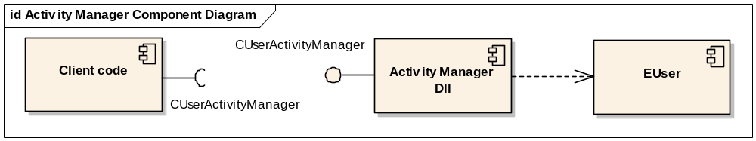
Figure 1 – Activity Manager Component Diagram

Detailed Design

Overview
The activity manager consists of one class, CUserActivityManager. This class provides services to monitor for activity and inactivity.

UML Diagram
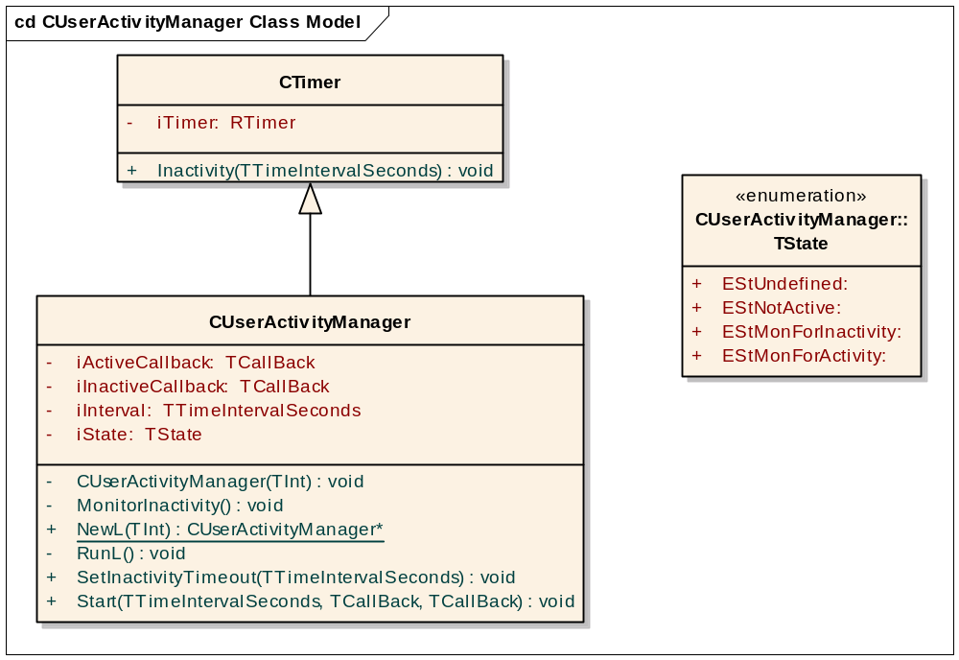
Figure 2 - Activity Manager Class Model
Clients construct the object using NewL() and call Start() to register call-backs to begin [in]activity monitoring. Monitoring continues until the object is destroyed. Clients can call SetInactivityTimeout() to adjust the inactivity interval once started. Call-backs supplied by clients should:
- complete quickly with minimal blocking.
- never call CUserActivityManager APIs as re-entrancy is not supported.
- never leave otherwise it can lead to panics.
For a more detailed description of each API please see the in source documentation and the BAFL how to FAQ /R3.

Design Unit Behaviour
The activity manager makes use of RTimer to monitor the inactivity and activity events. RTimer uses the kernel timer services. The usage of RTimer::Inactivity() requires awareness of the following characteristics:
- The document for RTimer::Inactivity states “If there has already been a period of user inactivity greater than the specified interval, then the timer is set after the next user activity”. Therefore, careful consideration has to be made when the current inactivity is greater than the new interval to set (current inactivity > new interval). See the text below and Figure 5 for a description of how this is handled.
- Calling RTimer::Inactivity() when the current inactivity is less than the new interval to set (current inactivity < new interval) also needs to be carefully handled. This API (via the kernel timer services) takes into consideration any elapsed inactivity time; therefore no re-calculations of time remaining are necessary. Again, see the text below and Figure 6 for a more detailed description of how this is handled.
- An undocumented feature of RTimer (via the kernel timer services) exists allowing one to monitor for user activity. To get RTimer to monitor and subsequently notify of a user activity event, simply call RTimer::Inactivity with an interval of zero seconds.
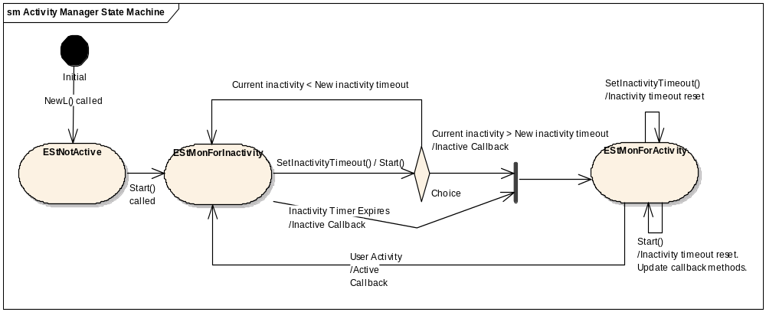
Figure 3 - Activity Manager State Machine
This diagram shows the dynamic behaviour of the activity manager. As can be seen from the diagram there are three states to the state machine (EStUndefined not included here as it is not a valid state). When the CUserActivityManager is created it moves into the EStNotActive state. A call to Start() will transition to the EStMonForInactivity state in which the inactivity monitoring will start.
When the inactivity timer expires a transition to the EStMonForActivity state will occur.
Notice that when the SetInactivityTimeout() or Start() event occurs within the EStMonForInactivity state a choice is made as to which state to transition to. This is because the user inactivity time that has elapsed up to this point is taken into consideration by RTimer (via the kernel timer services), so to be consistent with the RTimer internal state the CUserActivityManager must also consider this. So, if the current inactive period is greater than the new inactivity timeout requested than a transition to EStMonForActivity will occur. On the other hand, if the current inactivity is less than the new inactivity timeout then the state remains in EStMonForInactivity. The inactive period is determined by a call to User::InactivityTime().
In the EStMonForActivity state, the SetInactivityTimeout() simply results in the inactivity timeout to be reset. No transition occurs. This new timeout period will be used after transitioning back to the EStMonForInactivity state. Similarly, when Start() is called the inactivity timeout will also be reset. In addition, when Start() is called, the call-back methods are also updated (in case they have changed).
A transition from EStMonForActivity to EStMonForInactivity occurs when a user activity event occurs.

Scenarios

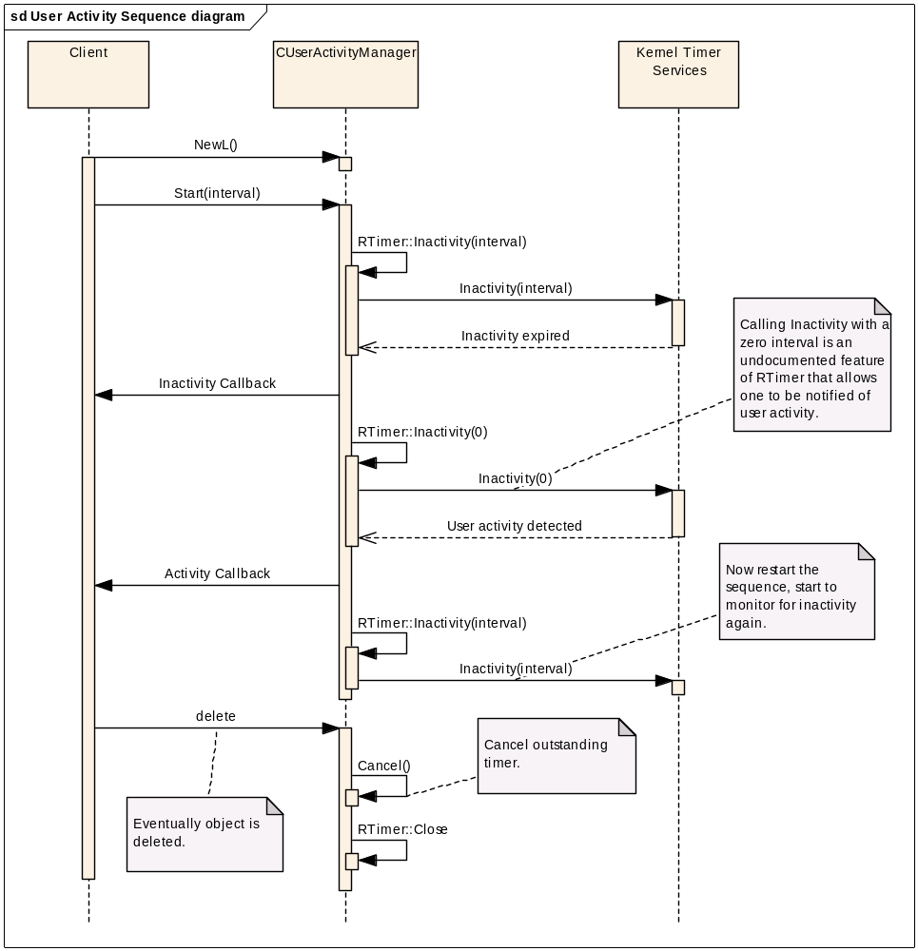
Figure 4 - Activity Manager typical sequence
This diagram shows a typical sequence of events, starting an Inactivity timer, followed by the transition to monitoring for user activity, and eventually the user activity event. Notice that once the sequence is started by a call to Start() it continues to go through the inactivity monitoring -> activity monitoring -> inactivity monitoring cycle until interrupted by a new Start(), SetInactivityTimeout() event or terminated by object deletion. Note that RTimer::Inactivity() is an internal call of CUserActivityManager, as CUserActivityManager is derived from CTimer, which contains an RTimer. For brevity the details of the kernel timer services are simply shown as a call to Inactivity(interval), when in reality EXEC calls are made to the kernel, followed by multiple internal calls in the kernel to Inactivity() methods and other various timeout methods.

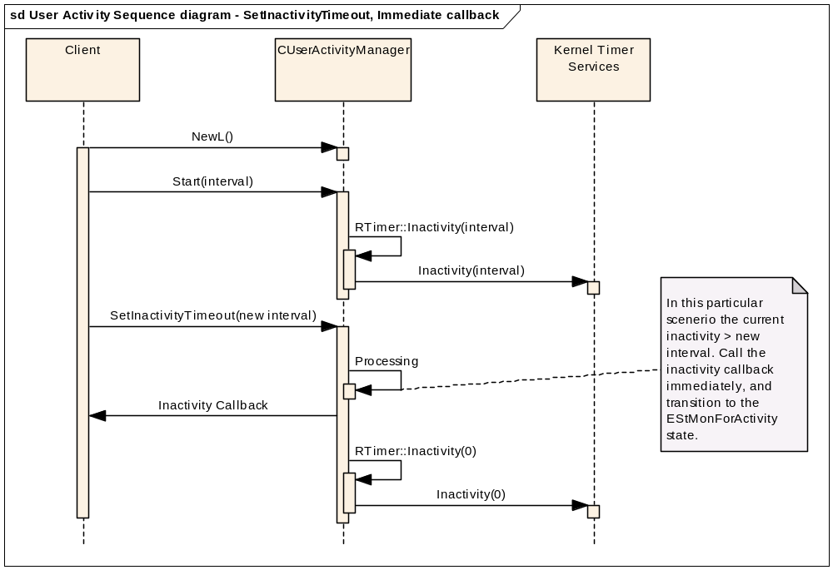
Figure 5 - Activity Manager - SetInactivityTimeout, Immediate call-back
This diagram demonstrates the sequence of events that occurs when a SetInactivityTimeout() event is injected during the EStMonForInactivity state when the current inactivity > new interval.

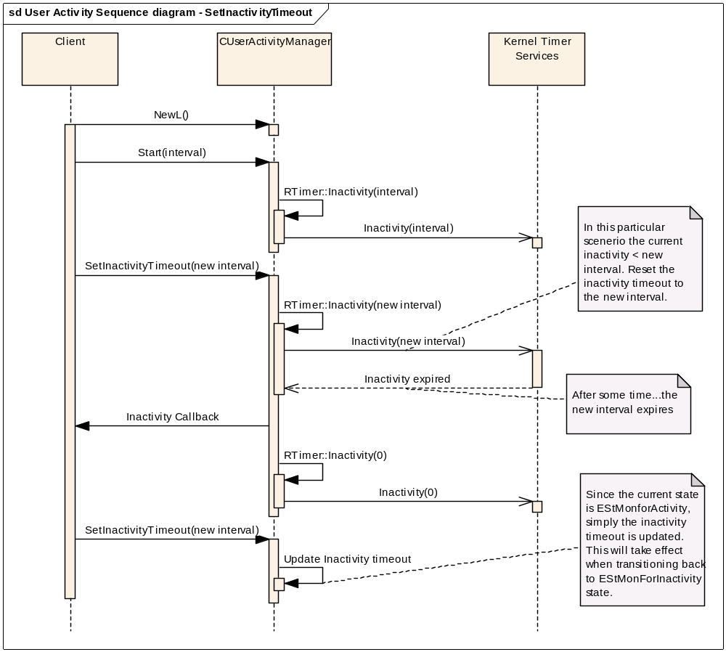
Figure 6 - Activity Manager, SetInactivityTimeout sequence
This diagram demonstrates the sequence of events that occurs when a SetInactivityTimeout() event is injected. The first part of the scenario shows the injection during the EStMonForInactivity state in which the current inactivity < new interval. The second part of the scenario shows an injection during the EStMonForActivity state.

Design Considerations

Configurability and impact on Master Codeline
System wide define of SYMBIAN_BAFL_ACTIVITYMGR for compilation purposes and inclusion into the ROM image.

ROM/RAM Memory Strategy

ROM Usage
ARMV5 UREL, activitymanager.DLL – 1305 bytes

RAM usage
24 bytes required for the CUserActivityManager class. One class needs to be created per client. Minimal transient RAM usage.

Performance considerations
When transitioning to the state EStMonForActivity the inactivity request is submitted before the call back is performed. This is to avoid missing any user activity should the call back take some time.

Error condition handling
This API uses "CUserActivityManager" category panics for its error strategy as it does not allow any path or mechanism to return errors. Therefore, any errors returned from the RTimer request (via RunL), such as KErrCancel, KErrArgument, KErrOverflow, will cause an ASSERT in debug and release builds. Note that the KErrOverflow error code is due to a limitation of RTimer. According to the RTimer documentation, KErrOverflow will be returned if the Inactivity() interval that is requested reaches its limit (which is platform specific but greater then one and a half day). This error code will be return immediately after the Inactivty() call.
Specific panics raised by APIs through improper use can be seen in the API documentation. KErrGeneral is raised when the internal state is irrecoverable.

Robustness issues
Designed so Start() can be called multiple times with no adverse affects. Also, Start() does not make any assumptions about state transitions. State transition is based on the current state and the inactivity timeout period that has elapsed.
In debug builds the Start() method will panic if the interval specified is less than one second, and will be set to one second in release builds.
In debug builds the SetInactivityMethod will panic if this method had been called before a call to Start().

Localisation issues
No localisation issues, as there are no language dependencies.

Hardware/Platform assumptions
No hardware/platform issues.

Compatibility considerations (Binary, Source, Data)
The activity manager DLL is a new DLL taken over from Nokia as part of the Core OS project. Any changes made to the interface have been agreed with Nokia, so there are no compatibility issues.

Interoperability considerations
No interoperability issues. No communication with outside device.

Platform Security
This is a general purpose DLL with capability All – Tcb.

Modularity
No modularity issues. Does not directly depend on any other components (other than EUser).

Testing
Component testing. See component test specification /R1for more details.

SysUtil Design

Design Overview
The SysUtil DLL is a static interface DLL providing the SysUtil and CDeviceTypeInformation interfaces. These interfaces provide various utility methods for applications. In particular, the SysUtil API provides functions to retrieve software and language package versions, MMC and FFS drive letters, device type information (e.g. Manufacturer Name, Model Name and Model Code) and the Symbian OS version number. It also provides functions for checking whether disk space has reached a critical level. Clients wishing to use these APIs must add the SysUtil library to their MMP file.

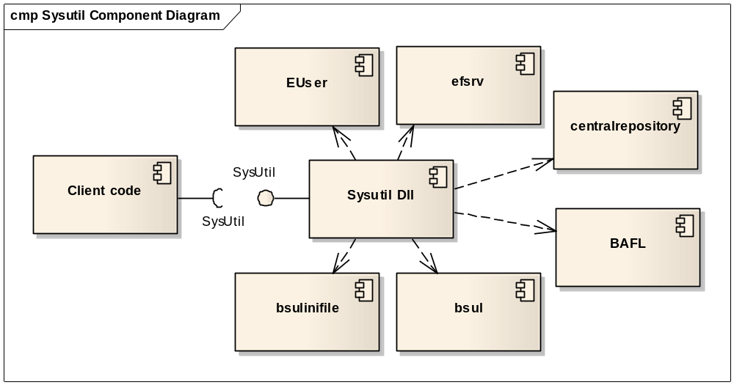
Figure 7 - SysUtil Component Diagram

SysUtil uses the File Server for all of the SysUtil APIs. Publish and Subscribe may also be used for all the APIs except when patchable data constants have been set. In this case the version and device type information APIs will read directly from the TXT and INI files and the disk level threshold APIs will use the patchable data constants instead. If neither the patchable data constants nor Publish and Subscribe properties are set then the disk level threshold APIs will attempt to use Central Repository. The Publish and Subscribe and Central Repository mechanism used by the disk level threshold APIs, as shown below in section 6.3, are provided for the convenience of previous users of these APIs.
Note that the preferable solution for fetching the MMC and FFS drive letters is via the patchable constants. If this fails bsul DLL will be used to retrieve this information.

Detailed Design

Overview
The SysUtil DLL consists of two classes which provide all the functionality. The main class is SysUtil which provides a set of static functions to retrieve software and language package versions, MMC and FFS drive letters and the Symbian OS version number. It also provides functions for checking whether disk space has reached a critical level and to retrieve an instance of the second class, CDeviceTypeInformation. CDeviceTypeInformation provides a set of APIs to retrieve the device identification attributes such as the Manufacturer Name, Model Name and UI Platform Name.
In addition to SysUtil DLL an executable, SysUtilSetup.exe, is provided to assist in the creation of Publish and Subscribe properties.

UML Class Model Diagrams and Descriptions
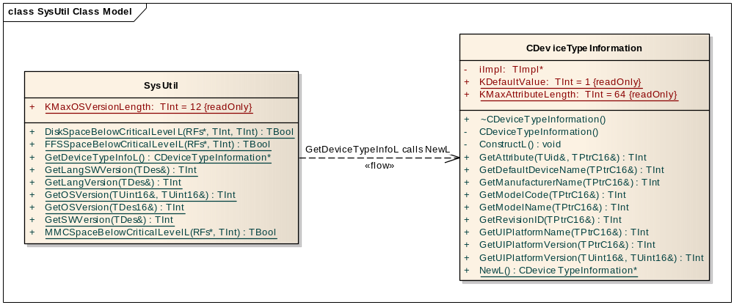
Figure 8 - SysUtil and CDeviceTypeInformation Class Models and relationship

SysUtil Class Model Description
The SysUtil class only provides static functions and does not maintain any state. It offers the following APIs:
- DiskSpaceBelowCriticalLevelL - Returns whether or not free disk drive storage space is or will fall below critical level.
- FFSSpaceBelowCriticalLevelL - Returns whether or not free FFS storage space is or will fall below critical level.
- GetDeviceTypeInfoL - Returns an instance of CDeviceTypeInformation which contains a copy of all the device type information.
- GetLangSWVersion - Retrieves a formatted version of the software version string with which the currently installed language package is compatible.
- GetLangVersion - Retrieves the version string of the currently installed language package.
- GetOSVersion - Retrieves the OS version. This can be in descriptor form or major and minor integer form.
- GetSWVersion - Retrieves a formatted version of the software version string.
- GetPRInformation - Retrieves a formatted version of the current software build i.e. product release information string.
- MMCSpaceBelowCriticalLevelL - Returns whether or not the free MMC storage space is or will fall below critical level.
RFs is an optional parameter that can be passed in for efficiency, so if the RFs connection has already been made then there is no need to open another one. The handle that is passed in must be a connected handle to RFs otherwise a panic will occur. If the parameter is not provided (set to NULL) then this class will create an RFs session internally.

CDeviceTypeInformation Class Model Description
The role of the CDeviceTypeInformation class is to provide an efficient way of storing the device type information. This class cannot be instantiated directly and instances must be created by calling SysUtil::GetDeviceTypeInfoL(). It offers the following APIs to retrieve the device type information:
- GetAttribute – Retrieves a reference to the attribute string which matches the provided UID.
- GetDefaultDeviceName - Retrieves a reference to the default Device name string. This value conveys the default name for the device as might be used for network identification e.g. Bluetooth nickname.
- GetManufacturerName - Retrieves a reference to the Manufacturer Name string.
- GetModelCode - Retrieves a reference to the Model Code string. This value conveys the internal model name or part number by which this model is known to the manufacture.
- GetModelName - Retrieves a reference to the Model Name string. This value conveys the model name of the device as recognizable by the end-user i.e. the consumer.
- GetRevisionID - Retrieves a reference to the Revision ID string. This value contains the device revision and/or variant identification string and conveys the specific version of the hardware and software used in the device.
- GetUIPlatformName - Retrieves a reference to the name of the UI Platform software used in the device.
- GetPlatformVersion - Retrieves either a string or major and minor integers representing the UI Platform version of the current UI platform software used in the device.
- NewL - Returns an instance of CDeviceTypeInformation. This member function is not exported and is called by SysUtil::GetDeviceTypeInfoL.

For a more detailed description of each API please see the in source documentation and the BAFL How To FAQ /R3. For details on the implementation of these APIs please see the scenario diagrams in section 6.3.

General Design Comments

Software and language version fetching APIs configuration
These APIs require a set of text files to be created in which the version information is stored. These files should be encoded in the UTF16 format and stored for each API as follows:
- GetSWVersion - The software version must be stored in Z:\resource\versions\sw.txt
- GetLangSWVersion - The software version must be stored in Z:\resource\versions\langsw.txt
- GetLangVersion - The version must be stored in Z:\resource\versions\lang.txt
- GetPRInformation - The product release information must be stored in Z:\resource\versions\purpose.txt
The text files for GetSWVersion, GetLangSWVersion and GetPRInformation must consist of only one line of text containing "\n" sequences which indicate new lines. This API will parse the string in the text file and remove any "\n" sequences that it finds and replace them with the Unicode new-line sequence - 0x000A. The resulting buffer is then a Unicode string with new-line sequences built in. This can then for example, allow the buffer to be displayed directly to the screen already formatted on multiple lines.
The text file for GetLangVersion should also contain only one line of text. This API does not have any new line sequence requirements as the above APIs do. This means that the string found in the text file should not contain any "\n" sequences and it will not require any formatting.

Device type information APIs configuration via INI files
The device type information APIs can be configured in few ways. The first is through an INI file, in UTF16 format, which is provisioned into the ROM by the device manufacturer. Some of the attributes will be different depending on the region in which the device is being sold. Therefore, in a non-composite ROM there maybe multiple INI files, each one for a different locale. These files will be stored in the same directory with the following naming convention:
- Z:\resource\versions\deviceattributes.i<locale_code> where <language_code> will be a number which corresponds with the TLanguage type.
If a file is not available for the set language then it will use the INI file which has the nearest language code.

In a composite ROM it is possible to have an INI file in each ROM section. This means that there could potentially be a locale specific INI file in each section and these files will all be stored in the same directory. To handle this, the following naming convention will be used:
- Z:\resource\versions\deviceattributes.i<language _code> for only the core ROM section (usually XIP).
- Z:\resource\versions\deviceattributes.i<language _code>[x-y] for other ROM sections where x is the ROM image id and at present y is unused and hence set to 0.
It is important to note that when a composite ROM is used the [x-y] suffix does not need to be appended to the name of the INI file. This is done automatically by the ROM builder providing that a special attribute is present in the iby/oby files. The attribute is "exattrib=U" and must be placed at the end of each ROFS image “data” entry, for the INI file, in the iby/oby files. For example:

main.iby
ROM_IMAGE[0] data=EPOCROOT##epoc32\data\z\resource\versions\deviceattributes.ini resource\versions\deviceattributes.ini

rofs2.iby
ROM_IMAGE[2] data=EPOCROOT##epoc32\data\z\resource\versions\deviceattributes2.ini resource\versions\deviceattributes.ini exattrib=U

In addition to this, if an INI file with the same name is found in a different section then the contents of the two files will be merged. If an attribute is found in more than one INI file then the most recent version of the attribute will be taken, i.e. the attribute from the INI file which appears in the highest ROFS section. For example, if ManufacturerName appear in deviceattributes.i02[1-0] and deviceattributes.i02[3-0], then the attribute value in the latter file would be used.
Finally, if no INI files are present or the format of the INI file is incorrect, then default values will be retrieved by all CDeviceTypeInformation APIs with the exception of GetAttribute which will return KErrNotFound.

For more information on the INI file please look at the separate documentation, [R3] BAFL How To FAQ .

Device type information APIs configuration via a plug-in
The second method of configuring the device type information requires configuration through the use of a plug-in. It is important to note that this is not an ECOM plug-in but a SysUtil specific polymorphic DLL. This method of configuration has several requirements. The plug-in DLL must:
- be given the name “sysutilplugin.dll”.
- be located on the Z drive. This is to avoid the DLL being overridden by a DLL of the same name being placed on the C drive.
- have WriteDeviceData and ReadDeviceData capabilities.
- export a function, which is the first ordinal, with the following signature:
void foo(RArray<TInt32>&, CDesC16Array&)
The exported header file, sysutilplugindef.h, contains the interface details regarding ordinal number and function typedef.

In addition to the plug-in DLL requirements the data also has some requirements:
- The first array, RArray, must contain a list of UIDs which are associated with a piece of device type information.
- The second array, CDesC16Array, must contain the device type information attribute values.
- The values in each array must correspond with each other, i.e. the UIDs in RArray must correspond to the device type information attribute values in CDesC16Array. This means each array should have the same number of elements.
- The UIDs must be in numerical order starting from low to high, e.g. 0x10286358, 0x10286359, 0x1028635A, etc.
- There must be no more than 450 device type information attributes.

If any of these requirements are not met then the plug-in DLL will not be used. In this case, if no INI files are present either, then default values will be retrieved by all CDeviceTypeInformation APIs with the exception of GetAttribute which will return KErrNotFound.
In addition to this, if the setup executable is disabled then the plug-in method of configuration will also be disabled. This is due to there being no guarantee that the client executable will have matching capabilities to the plug-in. This would lead to inconsistent behaviour. In this case the default values will be used for the pre-defined attributes.

Device type information APIs configuration via a plug-in and INI file
The final method of configuration is by providing a plug-in and an INI file. In this situation both sets of attribute values will be merged, with the values in the plug-in taking priority. This means if an attribute value is provided by the plug-in and it also appears in the INI file then the value from the plug-in will be taken. If a composite ROM is being used then the same rules apply to the INI files as documented in section 6.2.3.2.
If the provided plug-in and INI file are invalid (see sections 6.2.3.3 and 6.2.3.2 for more information) or neither are present then default values will be retrieved by all CDeviceTypeInformation APIs with the exception of GetAttribute which will return KErrNotFound.
In addition to this, if the setup executable is disabled then the plug-in method of configuration will also be disabled. This is due to there being no guarantee that the client executable will have matching capabilities to the plug-in. This would lead to inconsistent behaviour. In this case only the INI files will be used for configuration.

Critical level of drive space checking APIs configuration
These APIs require configuration of the following patchable data:
- Drive letter of the MMC drive
- Threshold for disk space critical level for a RAM drive.
- Threshold for disk space critical level for a non RAM drive.
- Drive letter of the FFS drive.
See the source code documentation and the BAFL How To FAQ /R3 for details of how to configure these constants.

OS version APIs configuration
The OS version APIs will have their data configured automatically at build time. This will be done via the use of an extension makefile which is located separately to the BAFL component. The location of this in the team branch is:
//EPOC/DV4/team/2008/texti18n/mcl/extension_makefiles/

The location of this in the MCL is:
//EPOC/master/cedar/generic/tools/buildsystem/extension/syslibs/

The job of the extension makefile is to run a Perl script, sysutil_setosversion.pl, which is located with the BAFL component. This generates a new source file in the following location:
/epoc32/build/generatedcpp/bafl/sysutil_osversion.cpp

This source file will define two constants, KOSMajorVersion and KOSMinorVersion which will be used by the OS version APIs.

Publish and Subscribe Read and Write policies
It is important that the ability to change the values in the Publish and Subscribe properties is restricted. This is necessary as the device type and version information is not meant to change after being read from the TXT and INI files. This protection will be provided by using a write policy that requires the correct Secure ID and the WriteDeviceData capability. To achieve this, a setup executable is needed so that the Secure ID is always known and so it can be given the correct capability.
In addition to this a read policy needs to be set. The read policy will not require a Secure ID or any capabilities. This is because there are no concerns about who reads the Publish and Subscribe properties. A special format is also being used for storing the device type and version information and so it would not be easy to use the information stored in the properties without a reasonable amount of processing.

Creation of Publish and Subscribe properties
In the case of all the APIs, with the exception of the drive letter and disk space checking APIs, the Publish and Subscribe properties will be loaded on demand. The reason for this is that the only other time to set these properties would be during system startup. This would increase the boot time, mainly due to reading files, and this is undesirable. As part of the load on demand functionality a setup executable is provided, sysutilsetup.exe. This is required for two reasons. Firstly, the properties category will be the SID of the executable. Secondly, the write policy of the properties will require the SID of the setup executable and the WriteDeviceData capability. This restriction is required for security reasons, see 6.4.10.
As a result of the overhead of loading a separate executable, the executable has been kept as lightweight as possible. However, it is possible to disable this setup executable for the Version APIs, the Device Type Information API or both if the overhead is considered too much. This will disable the caching feature and will change the behaviour so the configuration files are read each time.
The executables main job is to call one of two exported functions in sysutil.dll based on a flag which has been passed to it. It can also be used to help with testing and in this case it will call a third exported function in sysutil.dll. Table 1 shows the available flags and the functions which will use the flags when launching the executable. If no flags are passed then the exit code of sysutilsetup.exe will be KErrArgument meaning none of the Publish and Subscribe properties were defined and set.

Flag | Functions | Description
-a | GetLangSWVersion(), GetLangVersion(), GetSWVersion(), GetPRInformation() | Tells sysutilsetup.exe to read and process the language, language software, software and purpose TXT files. This is done by calling an exported function in SysUtil.dll which performs all the required work.
-v | GetDeviceTypeInfoL() | Tells sysutilsetup.exe to get the device type information from the plug-in and/or INI file. This is done by calling an exported function in SysUtil.dll which performs all the required work.
-delete | N/A | This flag is used for testing purposes only and will not work in hardware builds unless the KTestModeEnabled constant is patched to ETrue. When this flag is used the Version and Device Type Information Publish and Subscribe Properties will be deleted.
Table 1: sysutilsetup.exe flags
The reason for splitting the defining and setting of the properties in to two groups is to prevent the load on demand feature taking an excessive amount of time, due to potential reading and processing of the data in the INI and TXT files, It also allows for extensions to be made in the future should additional properties need creating. One other thing to note is how the properties have been split in to two groups. This has been done based on the expected use of the APIs.
If sysutilsetup.exe is not present in the ROM then the Publish and Subscribe properties will not be created. In this instance the SysUtil version information APIs will return KErrNotReady and the device type information API will leave with KErrNotReady.

Publish and Subscribe property format for version information
There will be a Publish and Subscribe property for each of the bits of version information (Language Version, Software Version, Language Software Version and Product Release information) which will have type EByteArray. This will allow each property to store up to a maximum of 512bytes which is more than enough and is the smallest type available to us. The first two bytes will be used to store an error code which will need to be cast to a TUint16. When the error code is being used it will need to be cast back again to a TInt16. All remaining space will be used to store the relevant piece of version information. In the case of the software, language software and product release versions, these will be stored in their processed form i.e. the newlines (\n) will have been replaced. This means the processing needs to be done only once.

Publish and Subscribe property format for Device Type Information attributes
It has been decided to store all the device attributes in a single Publish and Subscribe property. This has been done for the following reasons. Firstly, it have decided to predefine a set of standard device type information attributes; however, it is possible for device manufacturers to define other attributes as required. This could potentially result in a few hundred Publish and Subscribe properties being defined which is undesirable. Secondly, when SysUtil::GetDeviceTypeInfoL is called, a populated instance of CDeviceTypeInformation will be returned. This means that a copy of all the attributes will need to be retrieved for storage in this instance. If the attributes were all stored in separate properties then multiple calls to RProperty::Get would be needed. By using a single property only one call will be needed.
Below is a table showing the layout of the Publish and Subscribe property/CDeviceTypeInformation memory block.
Block | Byte Offset | Size  (bytes) | Description | Type
Memory Length | 0 | 2 | This is the number of TUint16 elements in the memory block. | TUint16
Number of Attributes | 2 | 2 | The number of device type information attributes that are stored in the memory. | TUint16
Attribute UIDs | 4 | 0 - 4n | These are the UIDs associated to each attribute. These are needed so it is known which attributes have been provisioned and in which order they are stored in the P&S property/memory block. Each UID takes up 4 bytes. | TUint32
Attribute Offsets | 4 + 4n | 0 - 2n + 2 | The offsets of each attribute in the memory block. An offset to the end of the attributes is also stored. This is done so the length of each attribute can be easily calculated. | TUint16
Error Codes | 4 + 4n + 2n + 1 | 0 - 2n | The error codes which were returned when retrieving the attributes from the plug-in and/or INI file. There need to be cast to TUint16s before they can be stored. | TUint16
Device Type Information Attributes | 4 + 4n + 2n + 2 + 2n | 0 - 2n * 64 | The device type information attribute values. The values are stored next to each other without any separator such as a null terminator. Each attribute has a maximum length of 64 UTF16 characters (with the exception of the major and minor UI version numbers which have a maximum length of 5 UTF16 characters). | TUint16*
Table 2: Layout of the device type information where n is the number of attributes.

There is a size limit on the Publish and Subscribe property of ELargeByteArray (65536bytes). For this reason a limit on the number of allowed attributes of 450 will be enforced. This figure has been calculated based on the sizes in Table 2. Using these sizes the maximum number of attributes which could be stored is approximately 481. However, it has been decided to lower the number to 450 to allow for any changes in the future.

Retrieval of device identification attributes
There is a good reason for creating a new class to provide retrieval APIs rather than adding them to SysUtil. In the IA Report, /R5, it was decided that due to the way the device type information would be used that the cleanest solution was to offer the type information in a T class. The reason for this was that it was expected that the majority of clients would require a few of the attributes at a time. By packaging the attributes in a T class, with public member variables, the cost of calling multiple APIs would be eliminated and it would make the client code cleaner.
However, it has since been decided, for a couple of reasons, that a T class would not be suitable. Firstly, it wouldn’t be easy or desirable to provide member variables that are TPtrC16 descriptors which point at the data held in the Publish and Subscribe property. If this was done it would easily allow any client to change the device type information. Secondly, it has also been decided to allow device manufacturers to define non-standard device attributes i.e. attributes that haven’t been pre-defined such as Manufacturer Name. This prevents us from having a member variable for each attribute.
It has been decided that a C class should be used. This class will own a block of memory on the heap which will be used to store the device type information. The information will be copied directly from the Publish and Subscribe property in to this memory, keeping the same format as in the property. The C class will provide several member functions to retrieve the standard attribute values. This will be done by setting client provided TPtrC16 descriptors to point the relevant piece of device type information in the heap memory. If a value has not been provisioned then the TPtrC16 will point to a default value. An additional API will be provided which uses UIDs to retrieve the required attribute. This again will set a client provided TPtrC16 descriptor to point to the correct location in this memory. However, it will not set this descriptor to point to a default value if the attribute is not present.

CDeviceTypeInformation design comments
It has been decided that it should not be possible to derive from this class and that any instances should be created by SysUtil. As a result a few decisions have been made about its design. The first is that NewL() will not be exported to prevent people creating an instance of the class with out calling SysUtil::GetDeviceTypeInfoL() which returns a CDeviceTypeInformation object. In addition to this its constructor and ConstructL() have been made private to prevent derivation. To add to this the NONSHARABLE_CLASS macro has been used. This prevents DLL-derivation which means that another class in a different DLL cannot be derived from CDeviceTypeInformation.
It has also been decided to hide the structure of the member variable. This has been done because there is no reason for any client to know how the data is stored by CDeviceTypeInformation and it prevents them from making any assumptions. This has been achieved by creating a dummy class which is the type used by the member variable. When the member variable is needed by any of the CDeviceTypeInformation APIs a reinterpret cast is used to cast it to the correct type.

Scenarios

GetSWVersion, GetLangSWVersion, GetLangSWVersion and GetPRInformation Scenario
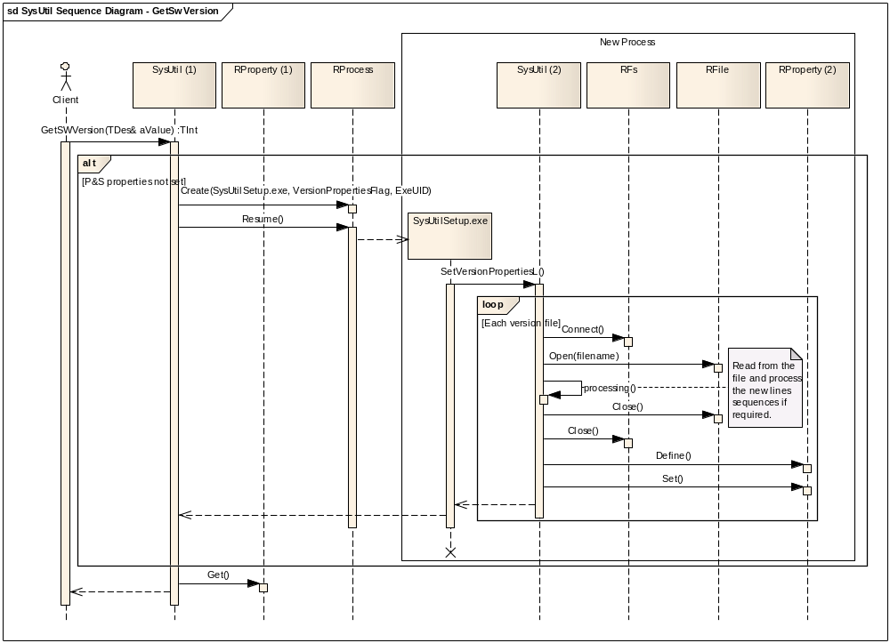
Figure 9 - GetSWVersion() sequence
The above diagram demonstrates how the GetSWVersion() API is implemented. On the first call to GetSWVersion() the version data needs reading from the text files and storing in Publish and Subscribe properties which need defining. On subsequent calls the Publish and Subscribe properties are already set so the data can simply be retrieved using RProperty::Get().
The GetLangSWVersion(), GetLangVersion() and GetPRInformation are similar, except as mentioned earlier, GetLangVersion() does no new line sequence processing. This means no new line processing will need to be done.

DiskSpaceBelowCriticalLevelL() Scenario
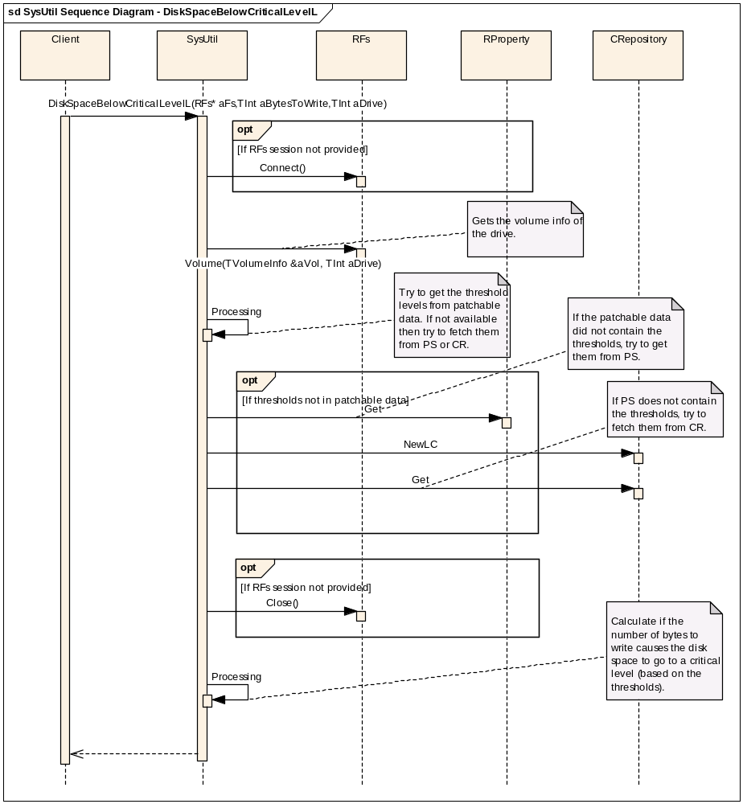
Figure 10 - DiskSpaceBelowCriticalLevelL() sequence
This sequence above shows the scenario that is used by all the disk threshold checking APIs. The thresholds will be attempted to be read from the patchable data. If the thresholds are not in the patchable data, than a Publish and Subscribe property will be checked. If that fails, or there is no threshold configured, then the Central Repository will be checked. If that fails, then an error is returned.
Assuming that a threshold is retrieved from one of the mechanisms above, than a calculation is performed based on the requested amount of data to write, and the thresholds, to determine if a critical level of disk space has been reached. The API will return a Boolean to notify the client if a critical level has been reached.

FFSSpaceBelowCriticalLevelL Scenario
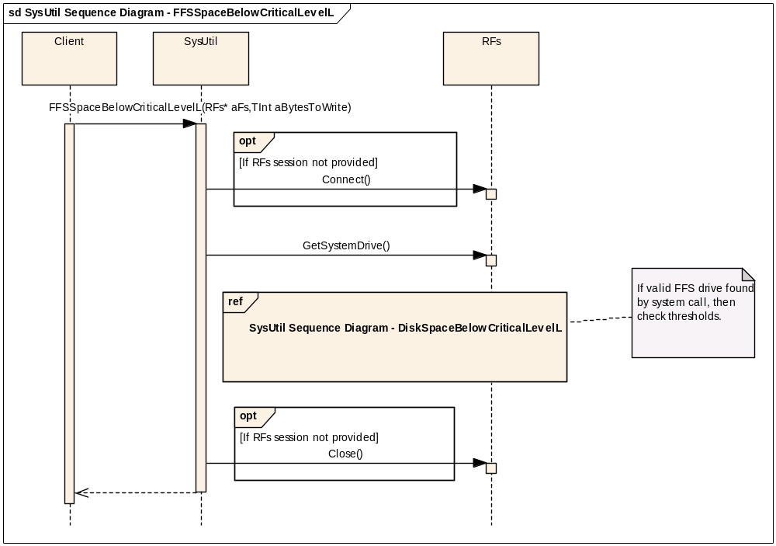
Figure 11 - FFSSpaceBelowCriticalLevelL() sequence
The FFS drive API will fetch the system drive from the RFs::GetSystemDrive() call. This must be configured before hand by a call to RFs::GetSystemDrive() (if not configured will return EdriveC by default). Once the FFS drive is determined then the DiskSpaceBelowCriticalLevelL() scenario will be executed, see Figure 10. The API will return a Boolean to notify the client if a critical level has been reached.

MMCSpaceBelowCriticalLevelL Scenario
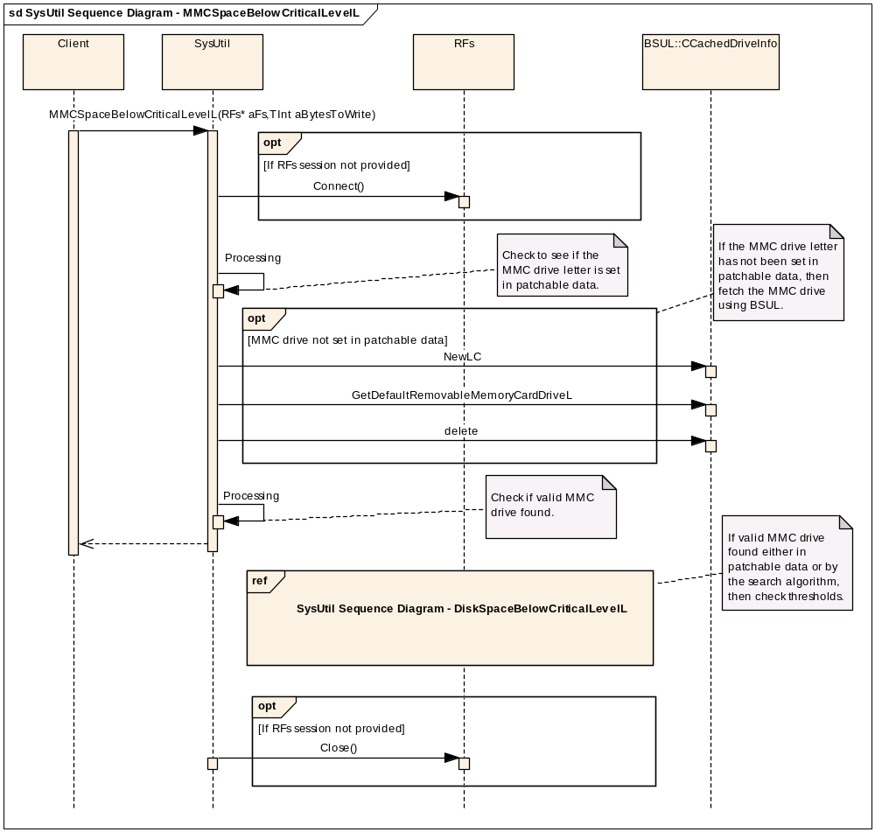
Figure 12 - MMCSpaceBelowCriticalLevelL() sequence
The MMC drive API will check first if the MMC drive has been configured in patchable data. If not, then it will fetch it from CcachedDriveInfo::GetDefaultMemoryCardDriveL(). Within BSUL the MMC card is determined by searching for the first drive that has drive attributes KdriveAttRemovable and KdriveAttLocal and is of media type EmediaHardDisk. This will be assumed to be the MMC drive on the device.
A valid MMC drive is one that is in the range of EdriveA to EdriveZ from the TdriveNumber enumeration.
Once the MMC drive is determined then the DiskSpaceBelowCriticalLevelL() scenario will be executed, see Figure 10. The API will return a Boolean to notify the client if a critical level has been reached.

GetDeviceTypeInfoL() Scenario
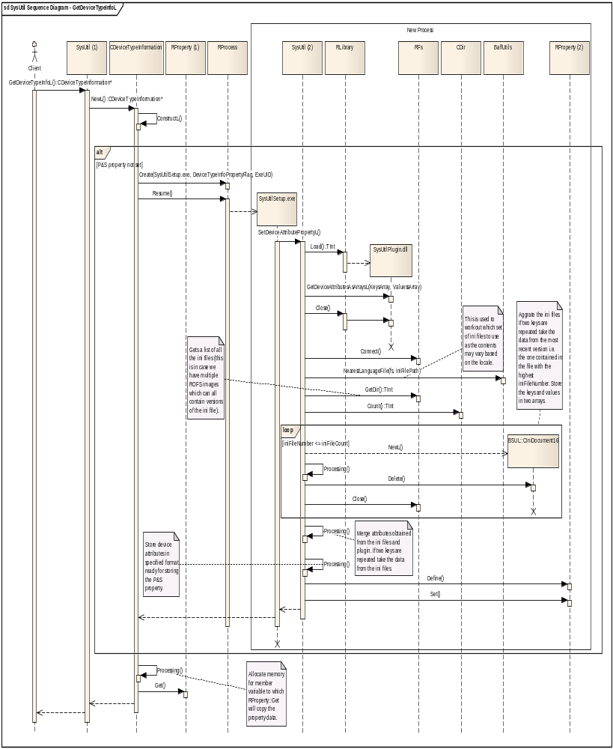
Figure 13 - GetDeviceTypeInfoL() sequence
The above diagram demonstrates how an instance of CDeviceTypeInformation is created. This is done by calling SysUtil::GetDeviceTypeInfoL() which then calls CDeviceTypeInformation::NewL (NewL cannot be called directly). On the first call to NewL the device type information needs retrieving from a plug-in DLL and/or reading from one or more localised INI files. If attribute data is retrieved from both a plug-in and one or more INI files then this data must be merged. Once this has been done the data needs to be processed so that it is in the required format to be stored in the Publish and Subscribe property. At this point the property is defined and set. On subsequent calls it is already set so no other work needs to be done other than retrieving the property data, which is then stored in a member variable. The client can then get access to this data by calling the provided getter member functions.

Design Considerations

Configurability and impact on Master Codeline
System wide define of SYMBIAN_BAFL_SYSUTIL for compilation purposes and inclusion into the ROM image.

ROM/RAM Memory Strategy

ROM Usage
ARMV5 UREL, sysutil.DLL – 6000 - 7000 bytes (estimated)
ARMV5 UREL, sysutilsetup.EXE – 1000 - 1500 bytes (estimated)

RAM usage
Minimal transient RAM usage on the stack for SysUtil as all APIs are static.
Minimal transient RAM usage on the stack for CDeviceTypeInformation as the only member variable is allocated on the heap. Heap memory usage is estimated to be between 125 – 200 bytes and can be a maximum of 64 kilobytes. However, it is very unlikely that this amount will ever be used.

Performance considerations
The disk space checking APIs allow passing in of an RFs handle to allow a performance improvement if an RFs session is available already.
The software version and device type information are loaded in to Publish and Subscribe properties to remove the need to read the same files multiple times as a result of calling the APIs multiple times. It has also been decided that the Publish and Subscribe properties should be loaded on demand to avoid any increase in boot time.

Error condition handling
The software version and CDeviceTypeInformation getter APIs will return an error code if an error occurs. The disk space checking APIs and GetDeviceTypeInfoL() will leave if an error occurs.

Robustness issues
A race condition exists in the disk level APIs. This can occur when the check for critical level has passed and an attempt to write to the disk is then made. It is possible that the disk’s contents could have been changed after the disk level API had been called but before the write occurs, thus potentially causing the write to fail. User’s of this API should be aware that the write is never guaranteed, and to catch any errors.

Localisation issues
The software version and disk space checking APIs have no localisation issues, as there are no language dependencies. The device type information is locale dependent. This means BAFL::NearestLanguageFiles() will be used to read in the correct set of INI files. If the INI files are missing for a locale then a set of default values will be supplied. This will be reflected by the return code of the CDeviceTypeInformation getter APIs.

Hardware/Platform assumptions
No hardware/platform issues.

Compatibility considerations (Binary, Source, Data)
The SysUtil DLL has been taken over from Nokia as part of the Core OS project. Any changes made to the interface have been agreed with Nokia, so there are no compatibility issues.

Interoperability considerations
No interoperability issues. No communication with outside device.

Security Threats and Measures

Assets table
Stakeholder  Asset name | Legitimate end-user | Provider of device content | Device manufacturer | Network operator
Device type and version information | None | Availability, Integrity. | Availability, Integrity. | None

Attackers and their motives
There are three areas that an attacker could potentially exploit. These are:
- Changing of the device type and version information stored in the INI and TXT files before the Publish and Subscribe properties have been defined and set.
- Changing of the device type and version information once the Publish and Subscribe properties have been defined and set.
- Creation of a plug-in (polymorphic DLL) to provision the device type information.
This information will be used by several other components, e.g. Bluetooth, and may be used by 3rd party applications. Any changes to this to this information could cause inconvenience and/or annoyance to the end user.

Risk analysis
There are no high level risks.

Protection measures
The protection measures for the three areas an attacker could exploit, listed above in section 6.4.10.1, are as follows:
- The INI and TXT files will be included in to the ROM by the device creator and so it won’t be possible for these files to be modified once in ROM.
- When defining and setting the Publish and Subscribe properties a setup executable will be loaded that will call the appropriate APIs in SysUtil.dll which carry out this task. This will then allow SysUtil.dll to define the properties category as that of the setup executable. This will prevent any other applications deleting and redefining these properties. In addition, the write policy will require the setup executables SID and WriteDeviceData.
- The setup executable has capabilities WriteDeviceData and ReadDeviceData. This means that the plug-in DLL will require these capabilities in order to be loaded. If the plug-in does not have these capabilities only the INI file will be used, if present. In addition to this, the plug-in will be located on the Z drive so no one will be able to override it by placing their own plug-in on the C drive.

Outstanding risks
There are no outstanding risks.

Required capabilities
SysUtil is a general purpose DLL and requires capabilities All -Tcb.
SysUtilSetup.exe requires WriteDeviceData for the Publish and Subscribe write policy and ReadDeviceData in case a plug-in is used. The plug-in will call APIs which require this capability.

Modularity
Depends on Publish and Subscribe, Central Repository, the File Server, bsulinifile, bsul and BAFL.
The Nokia starter server owns and is responsible for configuring the following Central Repository and Publish and Subscribe data:
Central Repository UID for disk level: KCRUidDiskLevel - 0x10205056
Keys:
const Tuint32 KDiskCriticalThreshold = 0x00000001;
const Tuint32 KRamDiskCriticalLevel = 0x00000002;
P&S category for disk level: KPSUidDiskLevel - 0x10009D91
Properties:
const Tuint32 KRamDiskCriticalThreshold = 0x00000001;
const Tuint32 KOtherDiskCriticalThreshold = 0x00000002;

Testing
Component and integration testing. See component test specification /R1 for more details.

MultipartParser Design

Design Overview
Multipart parser provides a MIME multipart parser that is capable of both parsing and composing multipart/mixed and multipart/related content (RFC 2045). It also uses the Quoted Printable and Base64 codecs.

Detailed Design

Overview
The multipartparser consists of two published classes and one private class. The MultipartParser class is used to read and create MIME multi-part messages. Each distinct ‘part’ is loaded into CBodyPart.
The GzipBufMgr is used to process gzip encoded content.
Please note: the Quoted Printable codec required was copied from TImCodecQP. Future development must be coordinated until further notice.

UML Diagram
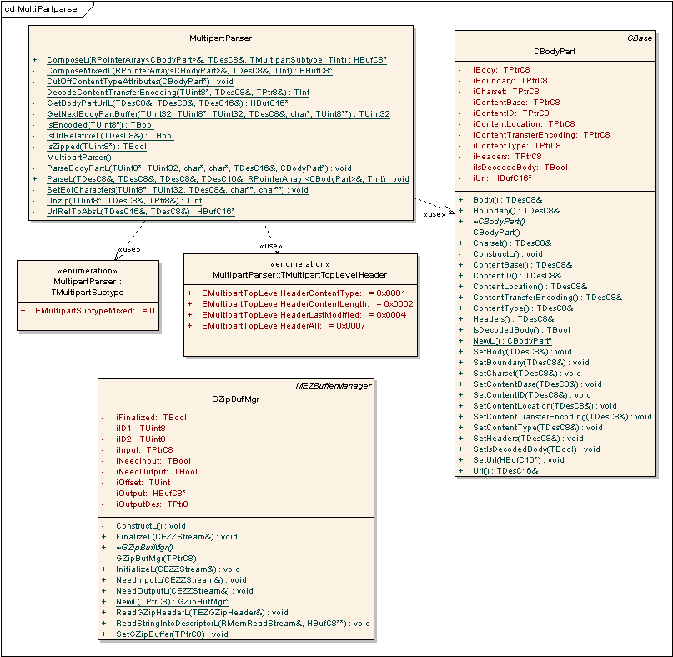

Design Unit Behaviour
The multipartparser is a static library that parses a MIME message into it’s respective bodyparts. The code using the multipartparser creates an array of bodyparts, loads the file, and then calls the multipartparser to parse the MIME file, storing each bodypart in an array of CBodyParts.
Please refer to the Functional Specification [R2] for more information on the behaviour of each class.

Scenarios
The code for parsing MIME messages is fairly simple. Error checking occurs throughout the code and an error code is returned once an error is encountered. Invalid parameters will raise a panic.
Parsing a basic MIME message is as follows is:
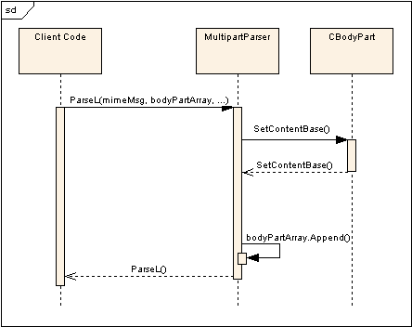
SetContentBase() is only one function of several that are used to fill the CBodyPart object. Other functions exist to set the content location, content transfer encoding, content type, content id. The content body is added using SetBody().
Parsing a Base64 encoded message is as follows:
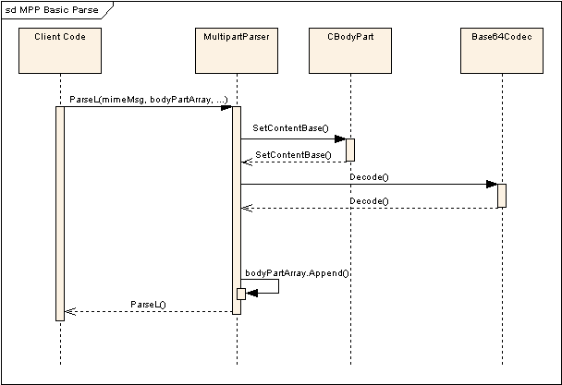
Quoted Printable (QP) Encoding works the same way, although it uses the QuotedPrintableCodec class instead of the Base64Coded.
And parsing a GZipped MIME message is as follows:
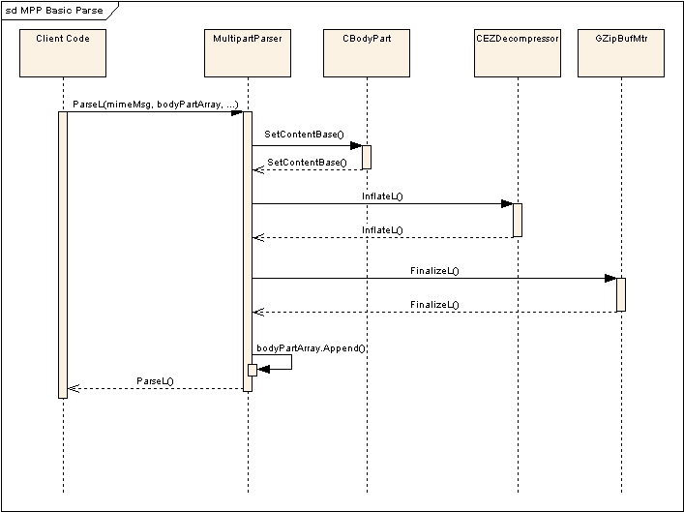

Composing a MIME message is even more simple. The client passes in an array of CBodyPart objects, which get assembled into a MIME formatted document.
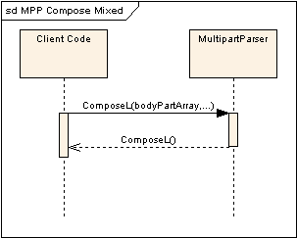
Please note that zipping and encoding are not part of the multipartparser assembling process.

Design Considerations

ROM/RAM Memory Strategy

ROM Usage
ARMV5 UREL multipartparser.dll – 6720 bytes

RAM Usage
Multipartparser is a static library with 20 bytes of data. A CBodyPart class is created for each body part in the original message and the calling application maintains an array of CBodyParts. Both the CBodyPart array and the original message are passed in.
CBodyPart is 84 bytes before it contains any message data loaded into it. The body part data is stored on the heap.
GZipBufMgr is 48 bytes with the output stored on the heap.

Error condition handling
This API uses E32 error codes, GZipBufMgr uses the EZLib range of errors. It will also return KErrCorrupt if the Quoted Printable codec is not QP compliant.
The API will panic when an invalid argument is passed in.

Robustness issues
The multipartparser DLL is a new DLL taken over from Nokia as part of the Core OS 2 project and has been used by Nokia in the field for a while.

Localisation issues
Localisation issues are partially handled by the codecs, however Charconv is used to convert between Unicode & UTF8.

Compatibility considerations (Binary, Source, Data)
The multipartparser DLL is a new DLL taken over from Nokia as part of the Core OS 2 project. Any changes made to the interface have been agreed with Nokia, so there are no compatibility issues. Any new changes must take into account the fact that this code has been out in the field for a while.

Interoperability considerations
The Quoted Printable codec required was copied from TImCodecQP. On a functional level there should be no interoperability issues, however on a code development level future development must be coordinated until further notice.

Platform Security
This is a general purpose DLL with capability All – Tcb.

Modularity
This component depends upon libc, libm, inetprotutil, estor, and ezlib.

Configurability and impact on Master Codeline
The system-wide define ‘SYMBIAN_BAFL_MULTIPARTPARSER’ is used to include the multipartparser in the ROM image.

Further Information

References
No. | Document Reference | Version | Description
[R1] | SGL.TS0017.203 | 1.0 | BAFL Test Specification
[R2] | SGL.TS0017.202 | 1.0 | BAFL Functional Specification
[R3] | SGL.TS0017.324 | 2.0 | BAFL How To FAQ
[R4] | SGL.TS0017.xxx | 0.1 | SysUtil INI File Format
[R5] | SGL.TS0017.657 | 1.0 | CR1328 IA Report

Open Issues
None

Glossary
Term | Definition
MMC | MultiMediaCard
FFS | Flash File System
QP | Quoted Printable Codec

Document History
This document is kept and maintained in the BAFL component folder in Perforce:
//EPOC/master/common/generic/syslibs/bafl/documentation/
An uncontrolled copy is also held in the Technology Stream folder:
V:\Dev\TS\TS0017 Base Services\RequirementsAnalysis\ProductRequirements\PREQ1802 - Adopt licensee extensions to Base Services and System Libraries
Date | Version | Status | Author | Description
21-07-2009 | 2.0 | For Review | Srinivas Chavva | Updated as part of DEF141094
12-11-2008 | 1.9 | Updated | Renota Schoepp | Added MultipartParser.
18-08-2008 | 1.8 | Issued | Francis Binns | Document issued after further CR1328 updates.
15-08-2008 | 1.7 | Draft | Francis Binns | Added information on “-delete- flag added to SysUtilSetup.exe
06-08-2008 | 1.6 | Issued | Francis Binns | Document issued after CR1328 updates.
05-08-2008 | 1.5 | For Review | Francis Binns | Updated to address final issues in the peer review.
28-07-2008 | 1.4 | For Review | Francis Binns | Updated to address issues raised in the peer review.
22-07-2008 | 1.3 | For Review | Francis Binns | Added security threats and measures information for SysUtil.
08-07-2008 | 1.2 | For Review | Francis Binns | Updated document for CR1328 - SysUtil API to return Device Identification and Version Information, after additional changes requested by Nile.
27-05-2008 | 1.1 | For Review | Francis Binns | Updated document for CR1328 - SysUtil API to return Device Identification and Version Information.
08-05-2008 | 1.0 | Issued | Stephen Mansfield | Document issued for Core OS 1 components in BAFL.
03-14-2008 | 0.3 | For Review | Jeremy Allen | Updated allocated UID section in appendix
19-11-2007 | 0.2 | For Review | Aaron Kranabetter | Updated after review by Will Bamberg and Aleks Pamir.
02-11-2007 | 0.1 | Draft | Aaron Kranabetter | First draft.
- Component UID Allocation Log
  - Summary
This appendix lists all the UID’s that are used by the BAFL component, and BAFL unit and component tests.
  - UID Allocations
    - Allocated UID Ranges
The following UID range has been allocated to SysUtil:
0x10285B39 – 0x10285B48 (hex)
271080249 – 271080264 (dec)
To date these have been allocated as follows:
UID | Component | Description
0x10285B39 | te_sysutilunitsuite.exe | The unit tests for sysutils
0x10285B3A | te_sysutilmanualsuite.exe | The manual tests for sysutils
0x10285B3B | sysutilsetup.exe | The 3rd UID for sysutilsetup.exe
0x10285B3C | KSWVersionUid | Publish & Subscribe UID for Software Version
0x10285B3D | KLangSWVersionUid | Publish & Subscribe UID Software Language Version
0x10285B3E | KLangVersionUid | Publish & Subscribe UID for Language Version
0x10285B3F | KDeviceTypeInfoUid | Publish & Subscribe UID for Device Attributes
0x10285B40 | KDebugFilePathsUid | Publish & Subscribe UID for Debug File Paths flag
0x10285B41 | Unallocated
0x10285B42 | Unallocated
0x10285B43 | Unallocated
0x10285B44 | Unallocated
0x10285B45 | Unallocated
0x10285B46 | Unallocated
0x10285B47 | Unallocated
0x10285B48 | Unallocated
0x20027BC4 | KPRInformationUid | Publish & Subscribe UID for Product Release information

0x10286358 – 0x10286377 (hex)
271082328 – 271082359 (dec)

To date these have been allocated as follows:
UID | Component | Description
0x10286358 | KManufacturerNameUid | Represents Manufacturer Name Device Attribute
0x10286359 | KModelNameUid | Represents Model Name Device Attribute
0x1028635A | KModelCodeUid | Represents Model Code Device Attribute
0x1028635B | KRevisionIDUid | Represents Revision ID Device Attribute
0x1028635C | KDefaultDeviceNameUid | Represents Default Device Name Device Attribute
0x1028635D | KUIPlatformNameUid | Represents UI Platform Name Device Attribute
0x1028635E | KUIPlatformVersionMajorUid | Represents UI Platform Major Version Number Device Attribute
0x1028635F | KUIPlatformVersionMinorUid | Represents UI Platform Minor Version Number Device Attribute
0x10286360 | Unallocated
0x10286361 | Unallocated
0x10286362 | Unallocated
0x10286363 | Unallocated
0x10286364 | Unallocated
0x10286365 | Unallocated
0x10286366 | Unallocated
0x10286367 | Unallocated
0x10286368 | Unallocated
0x10286369 | Unallocated
0x1028636A | Unallocated
0x1028636B | Unallocated
0x1028636C | Unallocated
0x1028636D | Unallocated
0x1028636E | Unallocated
0x1028636F | Unallocated
0x10286370 | Unallocated
0x10286371 | Unallocated
0x10286372 | Unallocated
0x10286373 | Unallocated
0x10286374 | Unallocated
0x10286375 | Unallocated
0x10286376 | Unallocated
0x10286377 | Unallocated

    - Individual UIDs
UID | Component | Description
0x100056e4 | Activity Manager | The 3rd UID for activitymanager.dll
0x10285A36 | Activity Manager test suite | The 3rd UID for te_activitymanagertestsuite.exe
0x10005943 | SysUtil | The 3rd UID for sysutl.dll
0x101FB3E7 | SysUtil test suite | The 3rd UID for te_sysutiltestsuite.exe
0x10205056 | KCRUidDiskLevel | Central Repository UID for disk level
0x10009D91 | KPSUidDiskLevel | Publish & Subscribe UID for disk level
0x10274CE2 | BSUL | The 3rd UID for bsul.dll
0x10274CE3 | Bsulinifile | The 3rd UID for bsulinifile.dll
0x10003A0F | BAFL | The 3rd UID for bafl.dll
0x10004901 | Baksrv | The 3rd UID for baksrv.dll
0x10004900 | Baksrvs | The 3rd UID for baksrvs.dll
0x10000000 | t_stringpooltest.exe | The 3rd UID for t_stringpooltest.exe
0x101FD697 | MultipartParser | The 3rd UID for multipartparser.dll

